
Instructed by: Krista DeCarle

Pet First Aid Registration Form
Class Dates Requested: ____________________________________________

*You must attend the full course to receive your certificate*

Where: Sleep Rover Doggie Day Care 645 37th Avenu NE (2nd floor). Entrance through main doors.
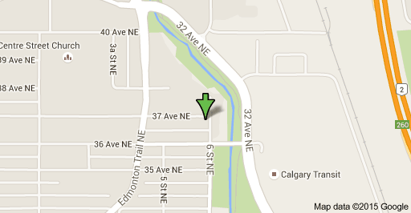

What to bring:
- Wear comfortable clothing
- Bring writing paper and pen/pencil
- While we do supply snacks & beverages, please plan for your lunch
- Dogs are welcome if registered ONLY.

Cancellations:

We will return full payment if a cancellation is made up to one week prior to the course date. Any cancellations after this time are subject to a $25 administration fee. Cancellations made within 48 hours of course will not be refunded. Once registered your space is non-transferable.

As seating is limited we ask that you return your registration and payment as soon as possible to secure your space. Your space in the course will only be confirmed once payment is received.

Course Date requested: _____________________________________
Name: ___________________________________________________
Address: __________________________________________________
__________________________________________________
Phone (please indicate if cell/home/office)
Email: ____________________________________________________
How did you hear about us? _____________________________
If referred by past student, name of that student _____________________________
Would you like to bring your dog? Y/N If Yes, Dog’s name: ___________________________
Breed: __________________________ Age: _______
There are a maximum number of dogs allowed to be registered and are accepted in order of registration. If we cannot accommodate your dog’s registration we will notify you prior.
**You are fully responsible for your dog and any actions they may take during the duration of the course. If your dog causes damages or injuries to anything or anyone, you solely will be held responsible for any incidentals to rectify the situation. Your dog must be obedient, relatively calm, can be quiet when required and sociable with other dogs & people as they may be handled by others during demos. We reserve the right to send any dog home if s/he is felt to be disruptive or unsuitable for the class. First aid is covered for cats but due to the environment we regret that cats are unable to come since dogs become too excited.**

OPTIONS:
____ $157.50 Course Fee w/gst:
____ $215.25 (w/Kit #1) w/gst:
____ $194.25(w/Kit #2) w/gst:
____ $170.10(w/Kit #3) w/gst:
Payment: _____ Cheque _____ Internet Transfer _____ PayPal
Receipts are available day of class.
Our Mailing Address:
Royal Pooch Pet Services
Attention: Krista DeCarle
Royal Oak RPO
PO Box 91088
Calgary, AB T3G 5W6

Signature: ________________________________________________
Date: ____________________________________________________

PET FIRST AID KIT #1 DETAILS ($55 + gst)
Weighing in at less than 2 lbs; this 75 piece pet first aid kit is highly water resistant and perfect for carrying in a backpack

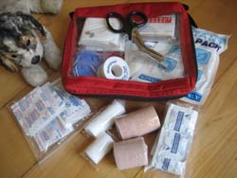
Contents:
2 - pair exam gloves
2 - Quality Conforming Gauze 5cmx4.1m/2inx4.5yd
1 - Quality Conforming Gauze 7.5cmx4.1m/3inx4.5yd
20 - 3" x 3" Sterile woven Gauze Pads;
1 - Quality Elastic Tensor Bandage 5cmx4.5m/2inx5yd
1 - Quality Elastic Tensor Bandage 7.5cmx4.5m/3inx5yd
1 - EMS utility Scissors 18 cm/7 in
1 - Adhesive Tape 2.5cmx4.5m/1inx5yd
1 - ABD Sterile Pad 20x25cm/8x10in2
2 - Triangular Bandages with sewn edges; pins
15 - Benzalkonium Chloride Antiseptic Towelettes; individually packaged
1 - Disposable Cold Pack
1 - Emergency Foil Blanket 137.2x213.4 cm/52x84 in
25 - Assorted Fabric Adhesive Bandages - for the humans!
1 - Water Resistant Carry Bag

PET FIRST AID KIT #2 DETAILS ($35 + gst)
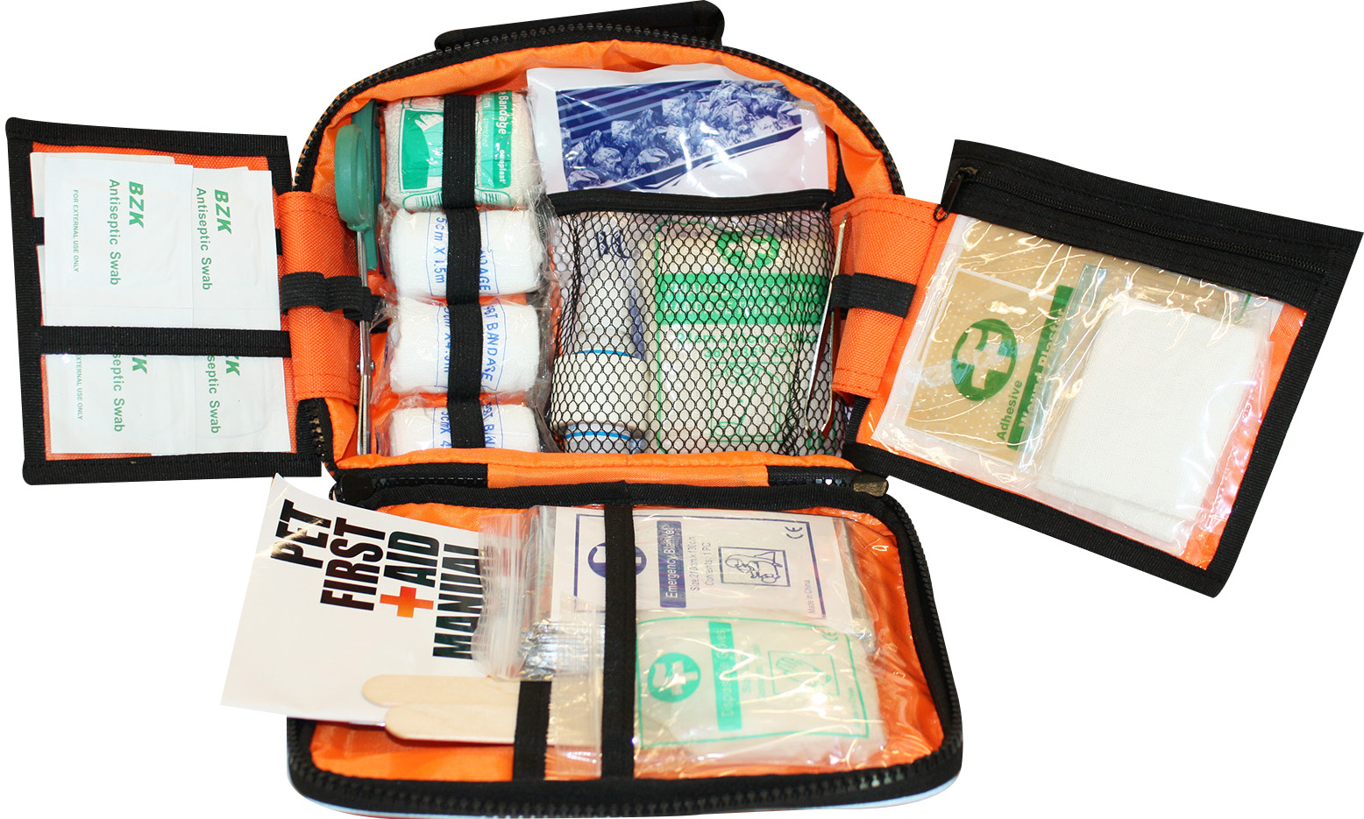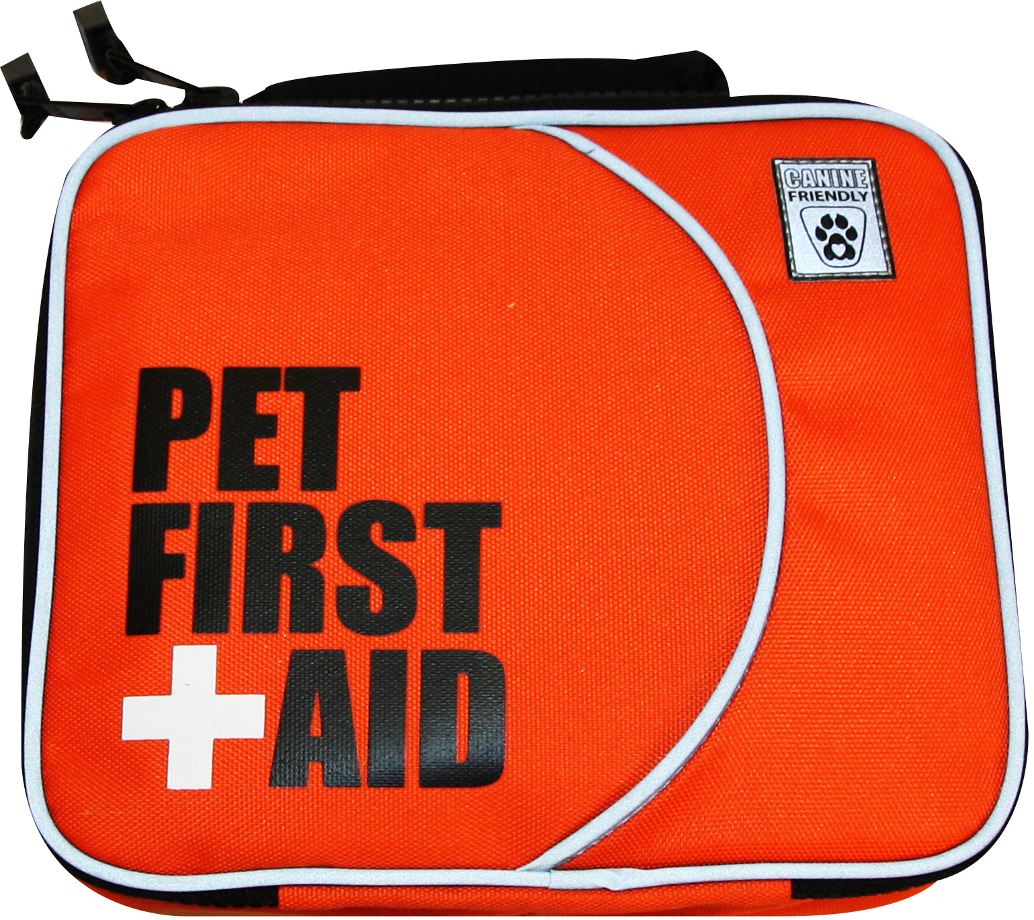
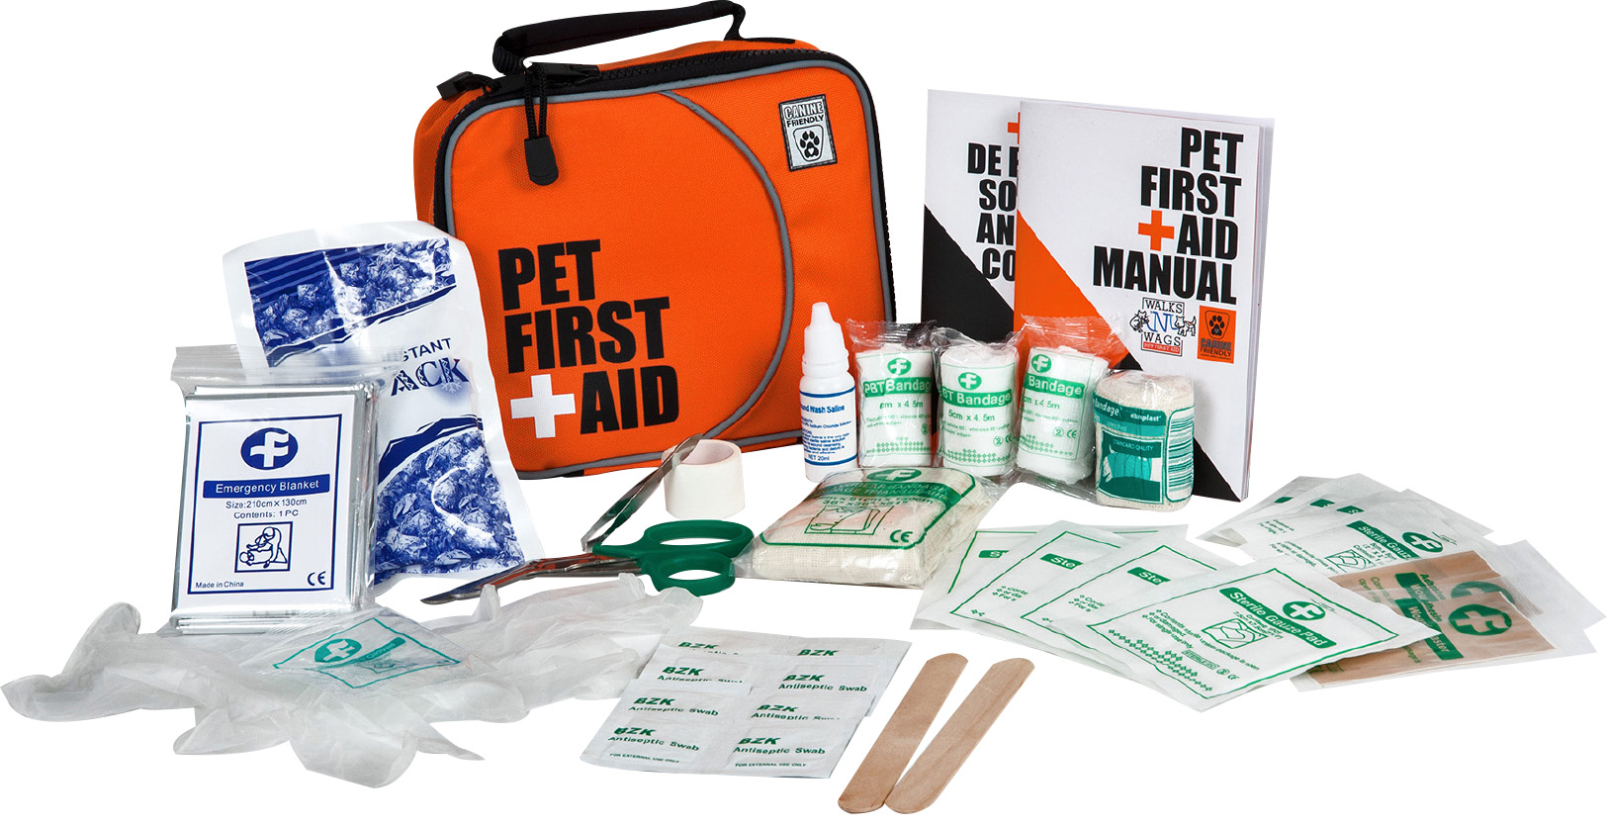
CONTENTS:
Gauze Rolls x 3 Square Gauze Pads x 4 Rectangle Gauze Pads x 4 Elastic Bandage x 1
Patch Adhesive x 2 Triangle Bandage x 1 Exam Gloves x 1 First Aid tape x 1
Tweezers x 1 Scissors x 1 Cold Pack x 1 Saline Solution x 1
Antiseptic Wipes x 8 Wooden Tongue Depressor x 2 Emergency Foil Blanket x 1
Walks 'N' Wags pocket First Aid Manual x 1

PET FIRST AID KIT #3 DETAILS ($12 + gst)
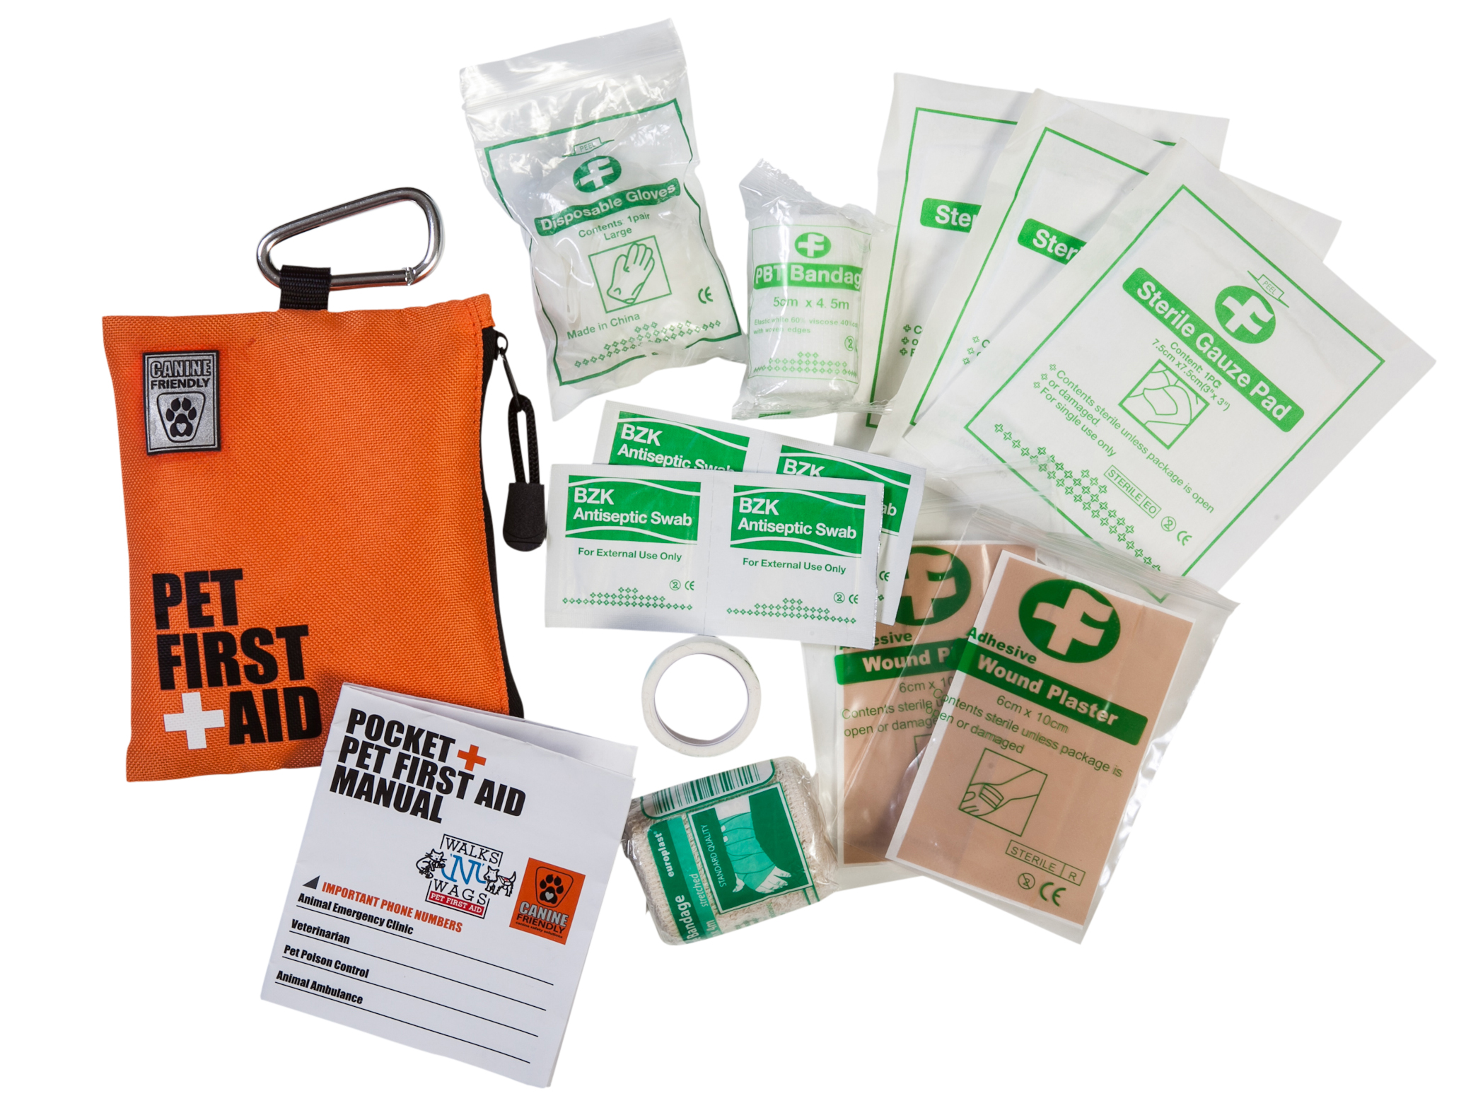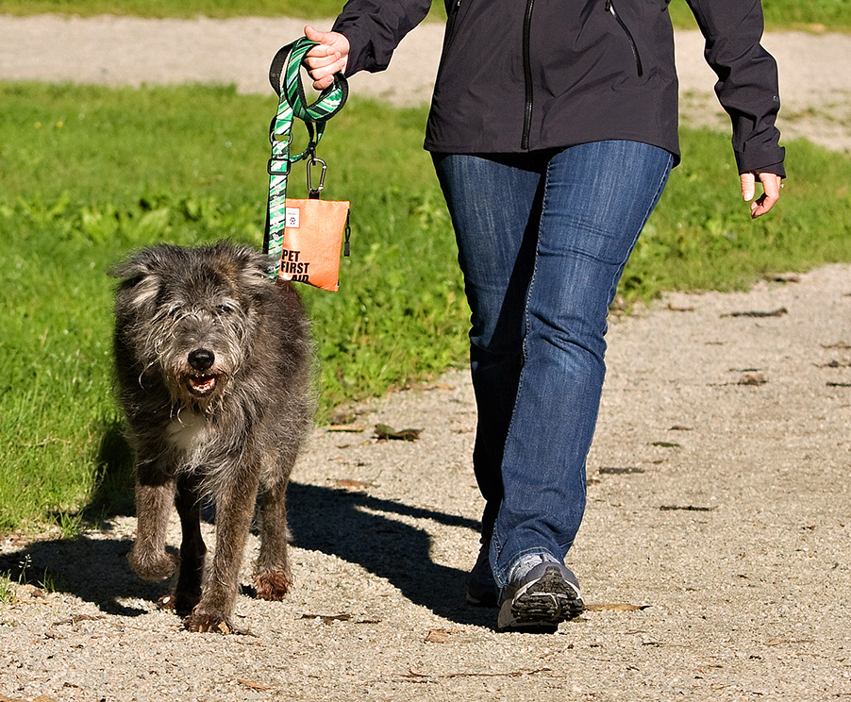
Perfect for dog walkers! The new Pocket "Canine Friendly" Pet First Aid kit was co-designed by Walks 'N' Wags and manufactured by RC Pet Products. This kit weighs about 1/4 lb and doesn't disappoint. Durable bright orange fabric is highly visible. Walks ‘N’ Wags Pet First Aid Manual offers easy to follow instructions.
CONTENTS:
1 - Gauze Rolls 3 - Gauze Pads 1 - Elastic Bandage
2 - Adhesive bandage 1 - Latex-free Exam Gloves 1 - First Aid tape
4 - Antiseptic Wipes 2 - Wooden Tongue Depressor 1 - Walks ‘N’ Wags First Aid pamphlet

